NC Level 6 Beauty Care Briefing Document

# Course Codes

* TH1NCL6C25-F1GA (Granton)
* TH1NCL6C25-F1MA (Milton Road)

# Skin

The skin is the largest organ of the human body. It provides a tough, flexible covering and has many distinct functions. Every five days, a human sheds a complete surface layer of skin, a process known as desquamation. 80% of household dust is made up of dead skin cells.

There are 3 main layers that form the structure of the skin. These are –

* The epidermis
* The dermis
* Subcutaneous layer

The epidermis is the outermost layer of the skin and is made up of 5 different layers. The main function of the epidermis is to protect the deeper structures of the body from harm. The layers are from the outside in –

* Stratum Corneum
* Stratum Lucidum
* Stratum Granulosum
* Stratum Spinosum
* Stratum Basale

The dermis is the layer underneath the epidermis. It contains 2 layers called the –

* Papillary layer – this layer contains nerve endings and blood capillaries.
* Reticular layer – this layer contains the fibers that give the skin strength. These are known as collagen fibers. It also contains fibers called collagen. These allow the skin to stretch.

The innermost layer of the skin is called the subcutaneous layer. This layer contains fat cells which are also known as adipose cells. This layer forms a soft barrier for protection and insulates the body against the cold.

The main functions of the skin are

* Sensation
* Heat regulation
* Absorption
* Protection
* Excretion
* Secretion

An effective way to remember the functions of the skin is to remember the word – SHAPES!

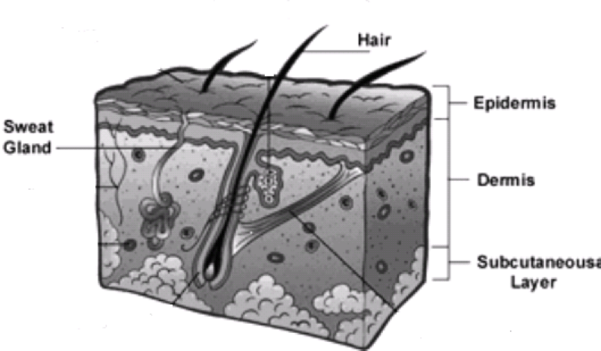

## The Pilo Sebaceous Unit

Every hair grows from a tiny tube that lies at an angle in the skin and opens onto the surface of the skin. It is known as the hair follicle. The base of the follicle is usually situated deep in the dermis where it has a supply of blood vessels to ‘feed’ it.

The functions of the hair follicle are to produce hair and secrete sebum (the oil that helps to keep our hair shiny and skin bacteria-free, soft, moisturised, and waterproof) from the sebaceous gland.

Because the hair follicle is an important part of the skin, there is a collective name for all the structures that are part of it. It is called the Pilo-sebaceous unit.

The Pilo-sebaceous unit is made up of:

* The hair
* The hair follicle
* The sebaceous gland
* The arrector pili muscle

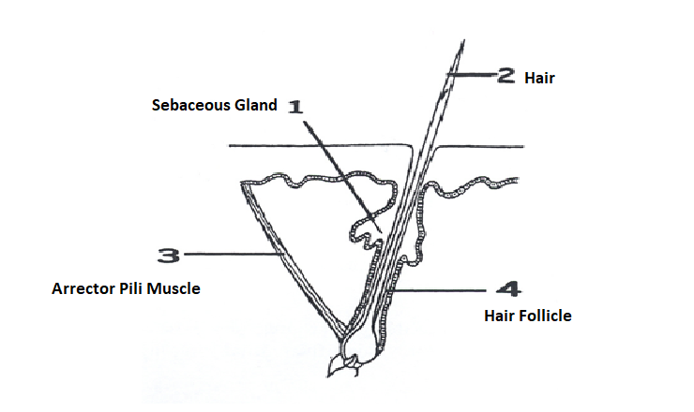

The arrector pili muscle is attached to the side of the hair follicle at its lower end and to the base of the epidermis at its upper end. When this tiny muscle contracts, it becomes shorter and acts as a lever, pulling the hair follicle vertically which makes the hair in the follicle stand straight up

You can see this happening on your skin when you are cold or when you get a fright; you know it as gooseflesh (or goosebumps). Your hair stands on end, and your skin looks bumpy. Your body does this to close the opening of the follicle so that you do not lose heat from your skin. Your hair is also made to stand on end to trap air and help to keep you warm.

In animals, this function is also designed to help scare off other animals as the long coat hair stands out and makes the animal look bigger and scarier

When you are no longer shivering you will notice that your skin goes smooth, and your hair lies flat on your skin again. This means that your arrector pili muscle has relaxed.