Spa Therapies (SCQF Level 6) Interview Briefing Document

# Course Code

TH1N6STD25-F1GA

## Facial Muscles

Facial muscles are divided into 2 distinct groups: facial expression and mastication muscles. The muscles of facial expression include the frontalis which raises the eyebrows and wrinkles the forehead. Risorius which draws the corners of the mouth out and back. Corrugator which draws the eyebrows down and together and Zygomaticus which raises the corners of the mouth up. The muscles of mastication are the muscles that move the jaw and aid the action of chewing. An example would be a Masseter that closes the jaw and clenches the teeth. Facial muscles have 3 different attachments, skin bone and other muscles.

Fig 1. shows the facial muscles with the muscles labelled.

Fig 1.

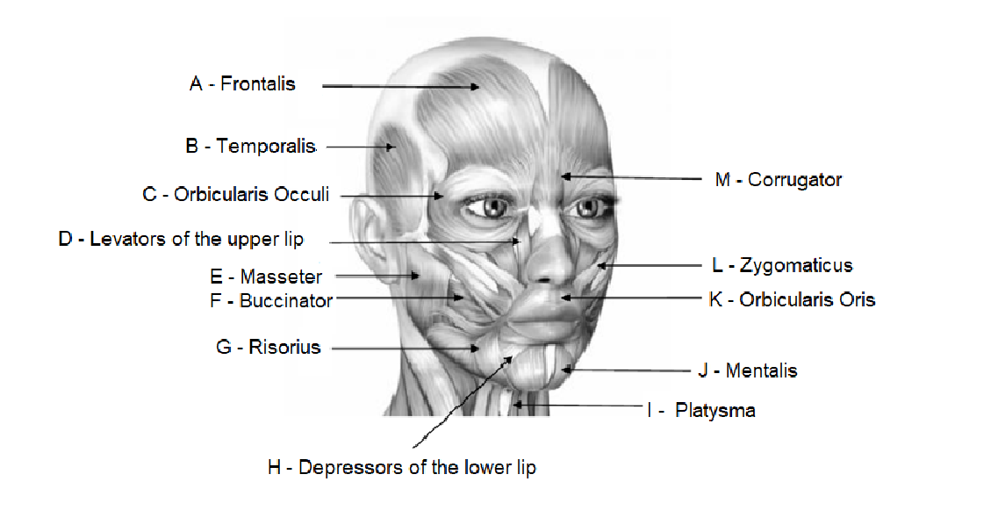

* A - Frontalis
* B - Emporalis
* C - Orbicularis Occuli
* D - Levators of the upper lip
* E - Masseter
* F - Buccinator
* G - Risorius
* H - Depressors of the lower lip
* I - Platysma
* J - Mentalis
* K - Orbicularis Oris
* L - Zygomaticus
* M – Corrugator

### The lymphatic system

The lymphatic system is closely related to the circulatory system

It consists of a network of vessels that assist the circulatory system to ensure adequate and efficient drainage from the cells and tissues

A healthy body requires an efficient drainage system to ensure the removal of waste products and toxins from the cells which would otherwise build up in the tissues and cause swelling (known as oedema) and poisoning.

The lymphatic system, unlike the blood circulatory system, has no ‘pump’ action (the heart) to help move fluid through the vessels.

It, therefore, relies on the squeezing action of skeletal muscle when it contracts to compress the lymphatic vessels and move the fluid along, draining it to the nodes.

The circulatory system consists of the heart, blood, and blood vessels. The heart acts as a pump for the blood, which, when oxygenated travels through arteries to the tissues of the body and travels back to the heart via the veins. The arteries are thicker-walled and elastic and do not contain valves. Veins have thinner walls as they do not carry blood under pressure and contain valves to prevent the backflow of blood.

Blood is composed of Plasma, Erythrocytes, Leucocytes and Thrombocytes and its main function is transport, defence, clotting, and heat regulation.